International Islamic University Chittagong Department of Computer Science & Engineering(CSE)

Course Code : EEE-1222  
Course Title : Electronics Sessional  
Lab Report : 07  
Experiment Name : Introduction to Op-Amp Circuits.  
Submitted to : Mohammad Hasin Abrar  
 Assistant Lecturer  
Submitted by: Montasir Tasnim Al Rafi  
ID No : C193079  
Email : C193079@ugrad.iiuc.ac.bd  
Semester : 2nd  
Section : 2BM  
Date of Submission : 30.12.2020

**Experiment Name:** Introduction to Op-Amp Circuits.

**Objective:** From this report we can learn that how to get a Full wave rectifier from through a correct design circuit.

**Circuit Design:**

**Schematic Version:**

**Circuit design**

**Inverting Amplifier**

RR

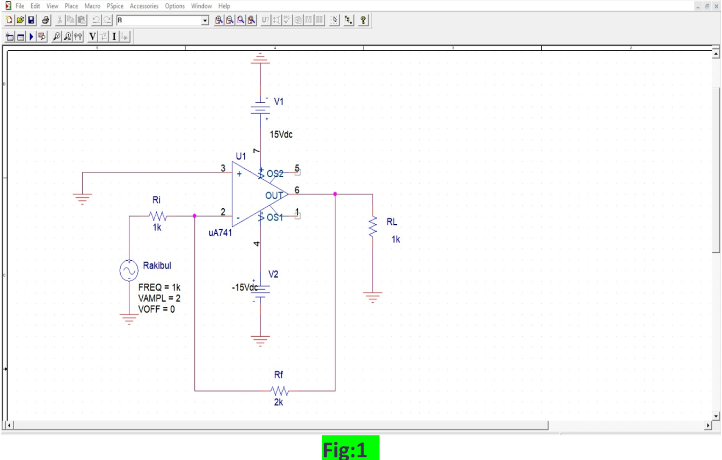

**Non-Inverting Amplifier**

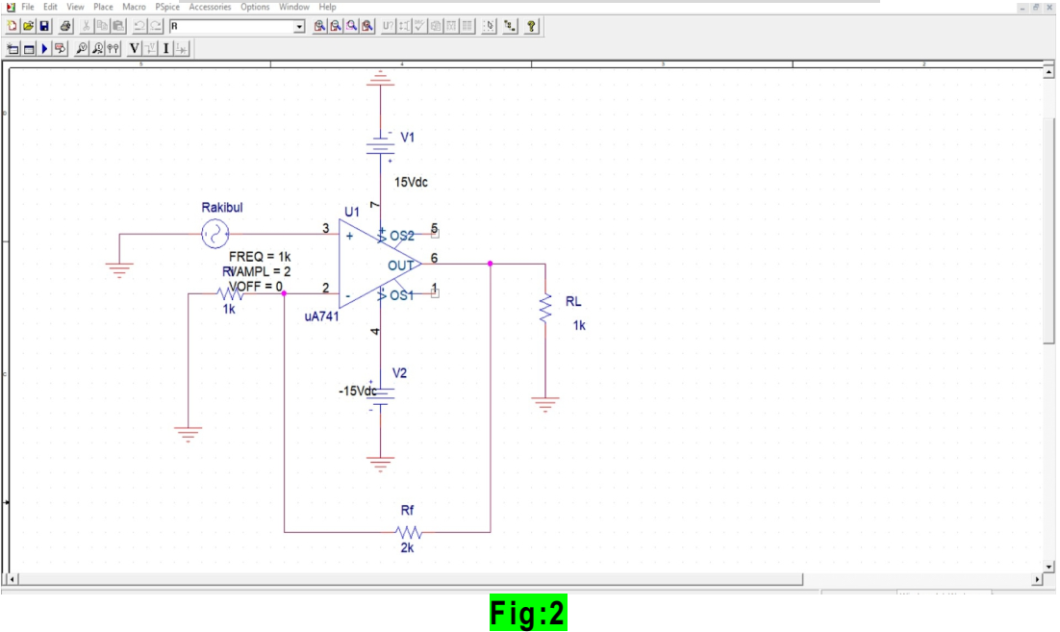

**Graph**

**Input and Output:**

**Inverting Amplifier**Here in the inverting amplifier circuit ,  
Vin = 2V ,  
Rf = 2k ,  
Ri = 1k ,  
Vout = - (Rf / Ri) x Vin  
= - ( 2 / 1 ) x 2  
= - 4

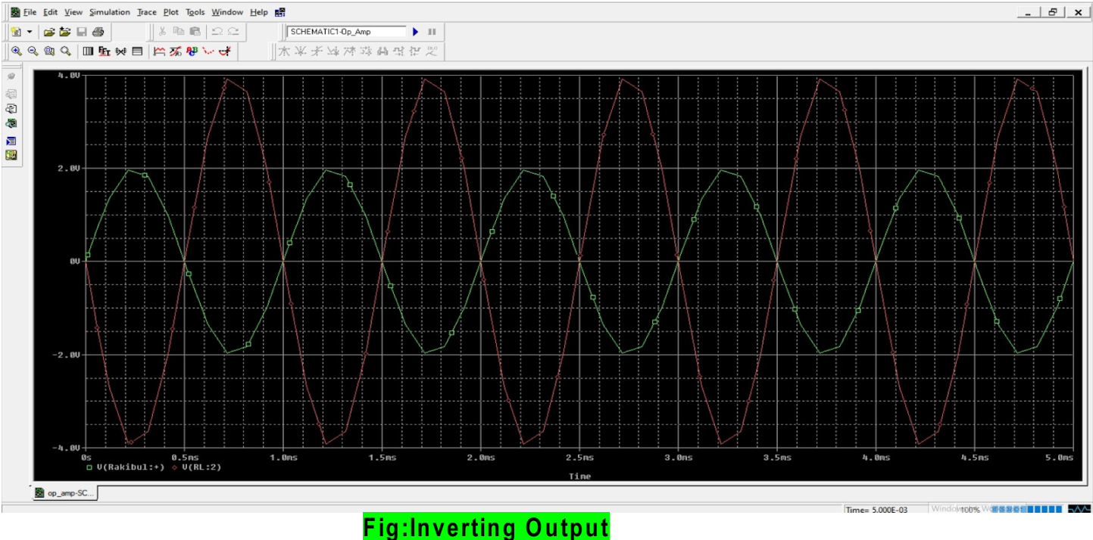

**Non-Inverting Amplifier**Here in the non - inverting amplifier circuit ,  
Vin = 2V ,  
Rf = 2k ,  
Ri = 1k ,  
Vout = ( 1 + ( Rf / Ri ) ) x Vin  
= ( 1 + 2 / 1 ) x 2  
= 3 . 2  
= 6

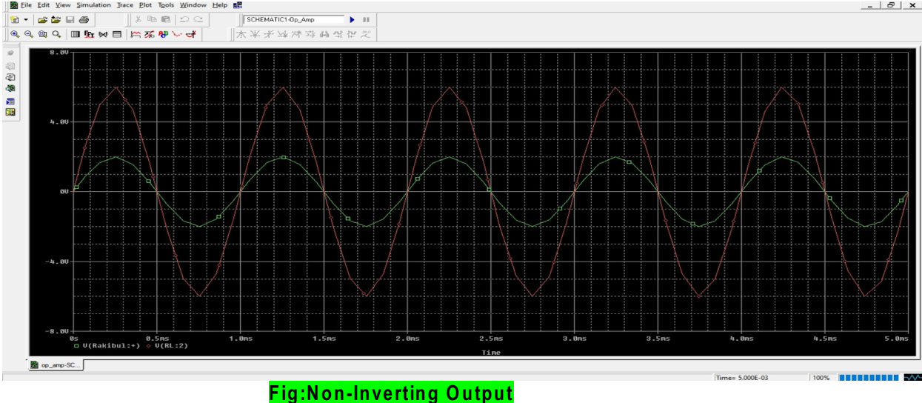

**Discussion:** From the PSpice software I can design a diagram by studying of Op-Amp circuit.